3.2 Limits and Continuity

Recall the definition of a limit from Calculus I.
Definition: Let be a function whose domain D includes points arbitrarily close to a. Then, we say that
the limit of f as x approaches a is L and we write if…
for every there is a corresponding such that if then .

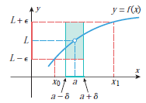

What this meant was that we needed to guarantee that a existed for every so that whenever it would be true that .

As we will discover, limits of functions of several variables is significantly more complicated than the limits of functions with one variable.

Definition: Let be a function of two variables whose domain D includes points arbitrarily close to . Then, we say that the limit of f as (x,y) approaches (a,b) is L and we write if…
for every there is a corresponding such that if and
then .

Explanation of the Definition: This definition is saying that if , then if someone challenges us with an (think of epsilon as small) we can find a circle centered at with radius such that every point in the domain that is inside the circle (not including ) produces a range value within of L when plugged into . An illustration of this idea is below:

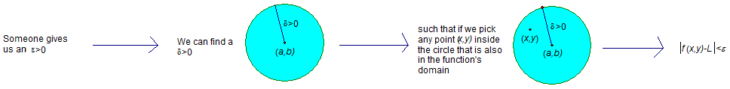

Question to the Class: In Calculus I and II when we dealt with limits like , from how many directions could we approach a?

There are two possible directions: the left and the right. Moreover, the limits from both directions need to agree in order for the limit to exist.

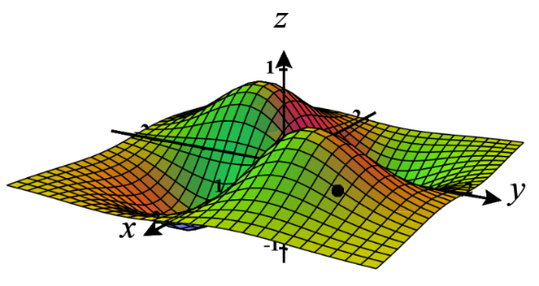
Question to the Class: When it comes to limits of the form , from how many directions can we approach ?

There are infinitely many directions from which we can approach , and in order for the limit to exist, the limit needs to be the same from ALL possible directions!

Remark: If …
as along a path and
as along a path where ,

then does not exist.

Example 1: Show that does not exist.
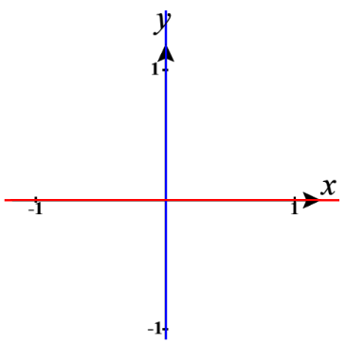
Suppose we approach (0,0) along the x axis. On the x-axis the y-coordinate is always 0. So, the limit becomes , and as along the x axis.

Now, suppose we approach (0,0) along the y axis. On the y-axis the x-coordinate is always 0. So, the limit becomes , and as along the y axis.

Since , we know that this limit does not exist.

Example 2: Show that does not exist.

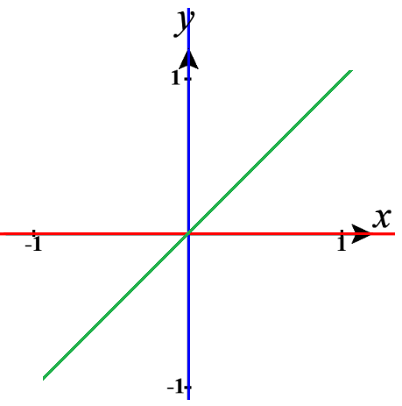
If we approach (0,0) along the y axis, the limit becomes: .
If we approach (0,0) along the x axis the limit becomes:
(this does not help us because it agrees with the first limit that we found).

Suppose we approach (0,0) along the line where m is some real number.
Then the limit becomes:
(this again does not help us because it agrees with the first limit that we found).

At this point it seems we need to approach (0,0) along a curve which will make the degree of the polynomial on top agree with the degree of the polynomial on bottom. Suppose we approach (0,0) along the curve , then the limit becomes .

Since as along the y-axis, and as along , we know that the limit does not exist.

Note: In the above example it was not necessary to calculate the limit along the x axis or along y = mx. However, in practice one has to be aware that he or she might check some paths that do not help in proving that a limit does not exist.

Note: In the above example we actually showed that the limit is 0 along infinitely many paths since m could take on infinitely many values. However, the limit STILL DID NOT EXIST because we could find some path that disagreed with the 0 limit. So, in this class checking paths will never lead to a justification that a limit exists.

We now turn to examples where the limit might indeed exist.
Extension of Limit Laws:
Suppose that c is a constant and the limits and exist. Then,
- &
- when n is a positive integer and f is nonnegative near when n is even.

Example 3: Find if it exists.

We note that . Now, by the limit laws, Thus, the limit exists and equals 0.

Note: If you tried to prove that the above limit does not exist, you would be unsuccessful because you would get a limit of 0 regardless of the path that you tried. From this point forward you do not need to be as detailed when applying the limit laws. Specifically, you may apply multiple limit laws at the same time.

Note: The instructor may illustrate the above example on the three dimensional plotter if time permits.

Example 4: Find if it exists.

First, we note that:
Finally, by the limit laws: .
Thus, the limit exists and equals 10.
Now that we are starting to understand the notion of two variable limits, we can introduce the concept of continuity.

Definition: A function of two variables is called continuous at if .
We say f is continuous on D if it is continuous at every point in D.

Remark: Intuitively, the meaning of continuity is that if the point changes by a small amount, then the value of changes by a small amount. Graphically if is continuous for all , the surface determined by has no holes or breaks.

Definition: A polynomial function of two variables is a sum of terms of the form , where c is a constant and m and n are nonnegative integers. A rational function is a ratio of polynomials.

Ex: is a polynomial function of two variables.
is a rational function.

Remark: The extension of the limit laws immediately imply that all polynomial functions are continuous on , and all rational functions are continuous on their domain. This observation makes evaluating some limits very simple.

Example 5: Answer each of the following questions.
- Find if it exists.

Suppose we let . Since polynomials are continuous we have that

- Find if it exists.

Suppose we let . Since is in the domain of , we know that is continuous at and .

Question: Could we have used the above strategy to find ?
- Is continuous at ?

No, it is not. In fact is not even in the domain of which means it is not possible for to hold.

Example 6:
- Is the function continuous at ? Explain.

No, it is not continuous at since it is not defined at (which means that does not hold).

- Is the function continuous at ? Explain.
We already showed in an earlier example that . Thus, we have that , and is continuous at by definition.

Remark: It can be shown (with a careful epsilon delta proof) that if is a continuous function of two variables and is a continuous function of a single variable that is defined on the range of , then the composite function defined by is also a continuous function.

Note: The above remark can be quite useful in explaining why and where certain two variable functions are continuous.

Example 7: Where is the function continuous?

We know from calculus one that the function is continuous for all real numbers. We know that is a rational function and is therefore continuous everywhere in except on the line .

We notice that . So, by the above remark we know that is continuous everywhere in except on the line .
As one might expect, the definition of limit of a function of two variables generalizes.

Definition: If is a function defined on a subset of then means that for every there is a corresponding such that if and then .

Remark: Like the two variable limit we need the limit to agree as we approach from all possible directions.

This means that if we want to prove a limit does not exist we must consider curves in . For example, if we wanted to see what the limit approaches along the z-axis, we would consider the limit along the curve .

Example 8: Show that the following limit does not exist: .

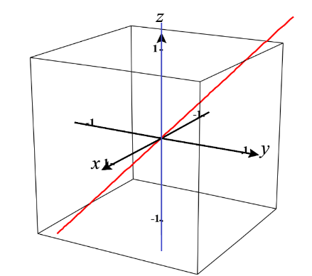
If we approach along the curve , the limit becomes .

If we approach along the curve , the limit becomes
.

Since the limit does not agree along these two curves we know that the limit does not exist.

Note: L’Hopital’s Rule does not apply for multivariate functions!

Example 9: Evaluate .

If we let , then we see that as it is the case that .
Therefore, we can say that
Now since we have reduced the limit to a limit in one variable we see that L’Hopital’s Rule applies and we calculate that.
Therefore, .

